EXPLORE ARMENIA

4N 5D YEREVAN

DAY 01: ARRIVAL –TRANSFER TO HOTEL

Depart from your country and start a nice journey to Caucasus Region. Arrive in Yerevan, the capital of Armenia. Our representative will meet you at the airport and will take to to Hotel

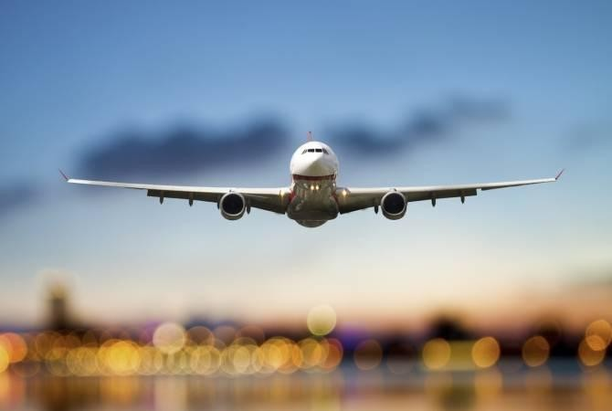

check in at Yerevan Hotel

DAY 2 -YEREVAN CITY TOUR
During the tour you will visit:
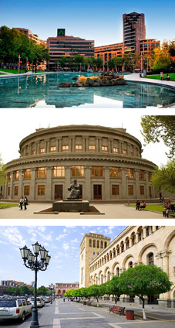
- MOTHER ARMENIA – a statue symbolises peace through strength, located in Victory Park.

- GENOCIDE COMPLEX - Armenia’s official memorial dedicated to the victims of the Armenian Genocide built in 1967 on the hill of Tsitsernakaberd.

- CASCADE - a giant stairway in the capital city which links downtown Kentron area of Yerevan with the Monument neighbourhood.

- OPERA HOUSE- deigned by the Armenian architect Alexander Tamanyan.

- REPUBLIC SQUARE- awaits you next. The Square is famous for the dancing water fountains located at the north-eastern end along the National Gallery.

- VERNISSAGE- If you are looking for some shopping during your holiday to Armenia, Vernissage is the place to be.

Check in at Yerevan Hotel
DAY 3- TSAGHKADZOR LAKE SEVAN

During the tour you will visit:

- LAKE SEVAN – the largest body of water in both Armenia and the Caucasus region.

- SEVANAVANK - set on a narrow peninsula, the Sevanavank Monastery has 2 stone churches to the 9th century.

- TSAGHKADZOR CITY - a spa town and urban municipal community, as well as one of the popular health resorts in Armenia.

- TSAGHKADZOR ROPEWAY ( optional ) - the arm chaired ropeway with 5 stations will take you to the top of the mountains to admire the breath-taking view.

- KECHARIS MONASTERY - a medieval Armenian monastic complex dating back to the 11th and 13th centuries.

Overnight in Yerevan.
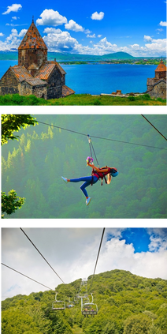

DAY 04 - GARNI GEGHARD
During the tour you will visit:

- CHARENTS ARCH – located on the road to Garni and is used as a spectacular place to view Mt. Ararat and valley.

- GARNI PAGAN TEMPLE - widely considered the country’s most important symbol of pre-Christian Armenia and admire the classical Hellenistic architecture you find.

- GEGHARD MONASTERY - unique caved temple, the name of which means “holy spear” in the honor of the long-preserved spear, the same spear that pierced the body of crucified Christ.

Overnight in Yerevan.

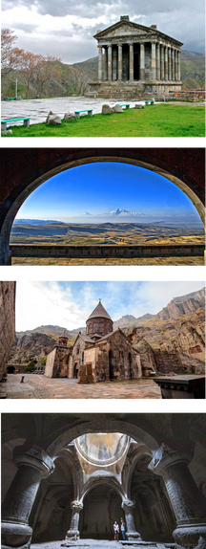

DAY 05 : DEPARTURE
Check out
Transfer to Airport. Have a nice and safe flight!!



Hotel | Per person price ( 2 Pax )  1 room | Per person price ( 3 Pax )  1 room | Per person price ( 4 Pax) 2 room
Yerevan Primer 3* | 290 USD | 220 USD | 216 USD
Bass Boutique 4 * | 352 USD | 256 USD | 278 USD
Best western Congress 4* | 460 USD | 351 USD | 358 USD
Ramada 4 * | 532 USD | 410 USD | 451 USD

Package Inclusions

- 4N Accommodation at chosen hotel
- Daily Breakfast Included at Chosen Hotel
- Return airport transfers and tours as per itinerary on private basis

Exclusions
- Tsaghkadzor ropeway fee ( 12 USD per person )
- Garni entrance ( 7 USD per person )
- Professional guide service

