EXPLORE ARMENIA

6N 7D YEREVAN

DAY 01: ARRIVAL –TRANSFER TO HOTEL

Depart from your country and start a nice journey to Caucasus Region. Arrive in Yerevan, the capital of Armenia. Our representative will meet you at the airport and will take to to Hotel

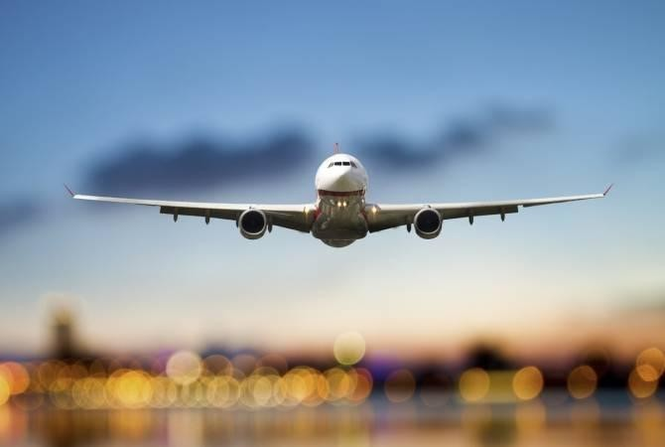

check in at Yerevan Hotel

Day 2 - GARNI GEGHARD & MANKUS EKO PARK
During the tour you will visit:

- CHARENTS ARCH – located on the road to Garni and is used as a spectacular place to view Mt. Ararat and valley.

- GARNI PAGAN TEMPLE - widely considered the country’s most important symbol of pre-Christian Armenia and admire the classical Hellenistic architecture you find.

- GEGHARD MONASTERY - unique caved temple, the name of which means “holy spear” in the honor of the long-preserved spear, the same spear that pierced the body of crucified Christ.

- Mankus Eco Park is a unique eco-friendly resort and leisure park where nature, adventure, and relaxation come together. It is designed for families, couples, and groups who want to enjoy a peaceful escape from the city.

Overnight in Yerevan

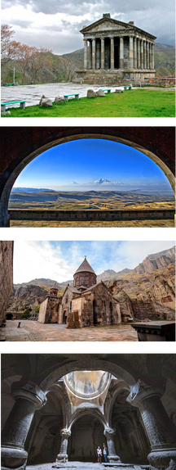

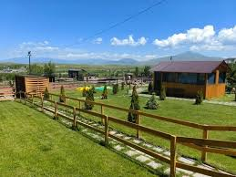

DAY 3- TSAGHKADZOR LAKE SEVAN

During the tour you will visit:

- LAKE SEVAN – the largest body of water in both Armenia and the Caucasus region.

- SEVANAVANK - set on a narrow peninsula, the Sevanavank Monastery has 2 stone churches to the 9th century.

- TSAGHKADZOR CITY - a spa town and urban municipal community, as well as one of the popular health resorts in Armenia.

- TSAGHKADZOR ROPEWAY ( optional ) - the arm chaired ropeway with 5 stations will take you to the top of the mountains to admire the breath-taking view.

- KECHARIS MONASTERY - a medieval Armenian monastic complex dating back to the 11th and 13th centuries.

Overnight in Yerevan.
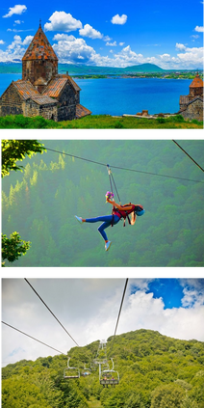

DAY 4 -YEREVAN CITY TOUR
During the tour you will visit:
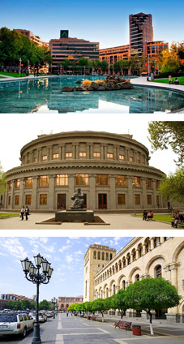
- MOTHER ARMENIA – a statue symbolises peace through strength, located in Victory Park.

- GENOCIDE COMPLEX - Armenia’s official memorial dedicated to the victims of the Armenian Genocide built in 1967 on the hill of Tsitsernakaberd.

- CASCADE - a giant stairway in the capital city which links downtown Kentron area of Yerevan with the Monument neighbourhood.

- OPERA HOUSE- deigned by the Armenian architect Alexander Tamanyan.

- REPUBLIC SQUARE- awaits you next. The Square is famous for the dancing water fountains located at the north-eastern end along the National Gallery.

- VERNISSAGE- If you are looking for some shopping during your holiday to Armenia, Vernissage is the place to be.

check in at Yerevan Hotel

Day 5 ; ALPHABET PARK MT ARAGATS SAGHMOSAVANK

During the tour you will visit:

- ALPHABET PARK - an alley of Letters that was built in honor to the 1600th anniversary of the creation of Armenian alphabet.

- KARI LAKE - an alpine lake in Armenia, situated on the slopes of Mount Aragats. Mount Aragats is considered to be the highest point of the Republic of Armenia at 4090 m from sea level.

- SAGHMOSAVANK – famous of its manuscripts. It was built in the village of Saghmosavank near the deep gorge of Qasagh river. Its excellent location provides more beauty to the monastery.

Overnight in Yerevan.
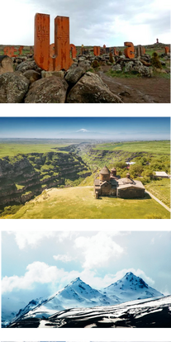

DAY 06: KHOR VIRAP NORAVANK ARENI WINERY

During the tour you will visit:

- KHOR VIRAP MONASTERY – located nedar the border of Turkey and Armenia, with wonderful views of Mount Ararat.

- NORAVANK MONASTERY - dates from 13th century and is completely different from other Armenian monasteries.

- ARENI WINERY – one of the main attractions for connoisseurs of vintage wines. The highlight is tasting new and mature wines from the local area.

Overnight in Yerevan.

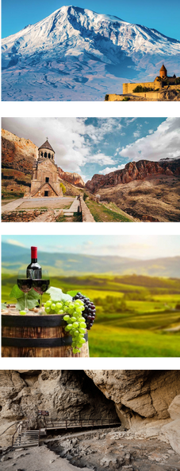

DAY 07 : DEPARTURE
Check out
Transfer to Airport. Have a nice and safe flight!!



Hotel | Per person price ( 2 Pax )  1 room | Per person price ( 3 Pax )  1 room | Per person price ( 4 Pax) 2 room
Yerevan Primer 3* | 438 USD | 328 USD | 320 USD
Bass Boutique 4 * | 524 USD | 391 USD | 400 USD
Best western Congress 4* | 686 USD | 509 USD | 534 USD
Ramada 4 * | 815 USD | 595 USD | 664 USD

Package Inclusions

- 6 N Accommodation at chosen hotel
- Daily Breakfast Included at Chosen Hotel
- Return airport transfers and tours as per itinerary on private basis

Exclusions
- Tsaghkadzor ropeway fee ( 45 AED per person )
- Garni entrance ( 25 AED per person )
- Professional guide service

