
PROPOSED ITINERARY

JAPAN AUTUMN DISCOVERY — 7 DAYS / 6 NIGHTS
Tokyo › Hakone 🍁 › Osaka › Kyoto 🍁 | | 17–23 November 2025

DESTINATION  Tokyo · Hakone Osaka · Kyoto | DURATION  7 Days / 6 Nights | TRAVEL Start DATES  17–23 Nov 2025 | GUESTS

DETAILED ITINERARY
DAY 1 | ARRIVAL IN TOKYO
Monday, 17 November 2025
Airport Transfer · Welcome Dinner · Hotel Check-in
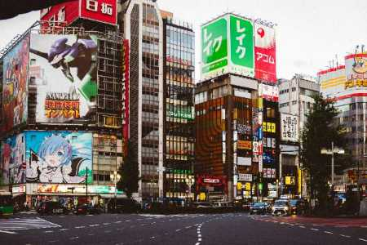
— | › | Airport transfer: NRT/HND → Hotel (upon arrival)
— | › | Check-in: Upper Upscale Hotel Tokyo (4–5★)
20:00 | › | Welcome dinner — Shinjuku Teppanyaki
21:30 | › | Evening stroll: Shinjuku neon lights & autumn illuminations
DAY 2 | TOKYO SIGHTSEEING
Tuesday, 18 November 2025
Asakusa · Harajuku · Shibuya · Kimono
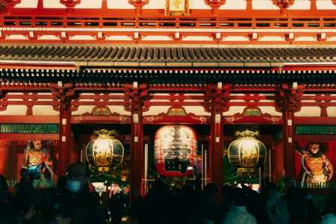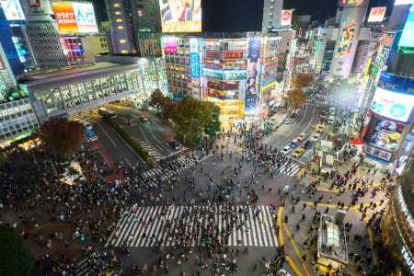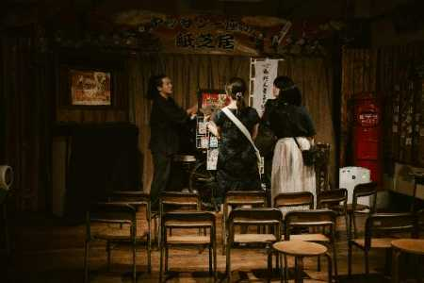
10:00 | › | Departure from hotel — Private Alphard (10hr hire)
10:30 | › | Asakusa: Senso-ji Temple & Nakamise Shopping Street
12:00 | › | Transfer to Harajuku / Omotesando
13:00 | › | Lunch — Japanese or International cuisine, Omotesando
14:30 | › | Harajuku shopping & Takeshita Street
16:00 | › | Shibuya Crossing & rooftop skyline views
17:30 | › | Kimono Wearing + Traditional Tea Ceremony
19:30 | › | Return to hotel
20:00 | › | Alphard hire ends
DAY 3 | TOKYO → HAKONE 🍁
Wednesday, 19 November 2025
Autumn Foliage · Ropeway · Lake Ashi · Onsen Ryokan
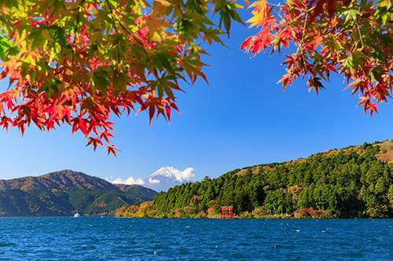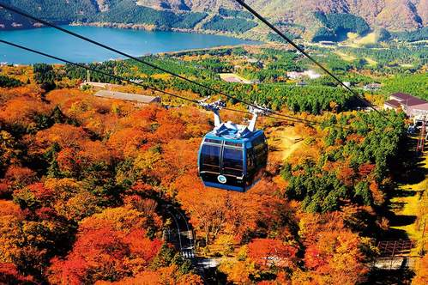
10:00 | › | Departure from hotel — Private Alphard (10hr hire)
11:30 | › | Arrive Hakone — Hakone Open Air Museum (🍁 autumn foliage)
13:00 | › | Lunch — lakeside restaurant with autumn views
14:30 | › | Hakone Ropeway — panoramic autumn foliage & Mt. Fuji
16:00 | › | Lake Ashi Cruise — autumn leaves reflected on the lake
17:00 | › | Check-in: Luxury Onsen Ryokan (4–5★)
18:00 | › | Private onsen & relax
19:00 | › | Kaiseki multi-course dinner at ryokan
20:00 | › | Alphard hire ends
DAY 4 | HAKONE → OSAKA
Thursday, 20 November 2025
Shinkansen Green Car · Osaka Check-in · Dotonbori
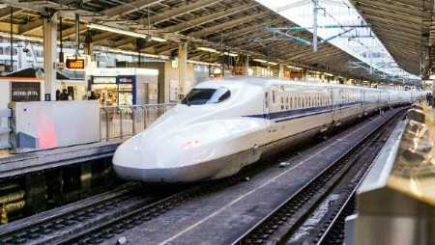
09:00 | › | Ryokan breakfast & morning onsen
10:00 | › | Private transfer to Mishima Station
10:45 | › | Shinkansen: Mishima → Shin-Osaka (Green Car / 1st Class)
12:15 | › | Arrive Osaka — Check-in: Upper Upscale Hotel (4–5★)
13:00 | › | Lunch — Shinsaibashi area restaurant
15:00 | › | Free time — Osaka Castle or Namba shopping
18:00 | › | Dotonbori night walk & Osaka street food
20:00 | › | Return to hotel
DAY 5 | KYOTO DAY TRIP 🍁
Friday, 21 November 2025
Fushimi Inari · Arashiyama Autumn 🍁 · Bamboo Grove · Samurai
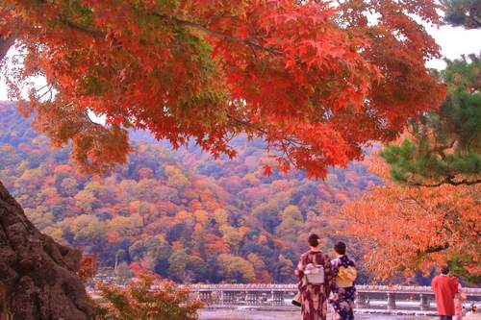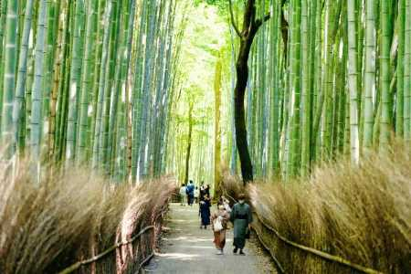
10:00 | › | Departure from hotel — Private Alphard (10hr hire)
11:00 | › | Arrive Kyoto — Fushimi Inari Taisha (🍁 autumn colours)
13:00 | › | Lunch — Kyoto Obanzai / Kaiseki light
14:30 | › | Arashiyama: Bamboo Grove & Tenryu-ji Zen Garden
15:30 | › | 🍁 Arashiyama autumn foliage stroll along Oi River
17:00 | › | Samurai Experience or Zen Meditation Session
18:30 | › | Return to Osaka
20:00 | › | Alphard hire ends
DAY 6 | UNIVERSAL STUDIOS JAPAN + SHOPPING
Saturday, 22 November 2025
USJ · Shinsaibashi · Farewell Dinner
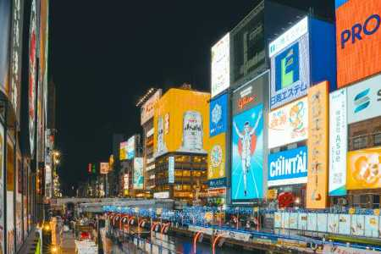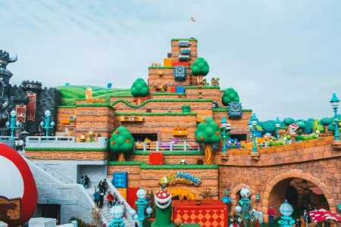
10:00 | › | Departure from hotel — Private Alphard (10hr hire)
10:15 | › | Arrive Universal Studios Japan (USJ)
10:30 | › | USJ opens — Full day (Express Pass strongly recommended)
13:00 | › | Lunch inside USJ
18:00 | › | Depart USJ
18:30 | › | Shinsaibashi / Amerikamura evening shopping
19:30 | › | Farewell dinner: Premium Wagyu Yakiniku or Osaka Kappo
20:00 | › | Alphard hire ends
DAY 7 | DEPARTURE FROM OSAKA
Sunday, 23 November 2025
Osaka Castle 🍁 · Kansai Airport · Sayonara!
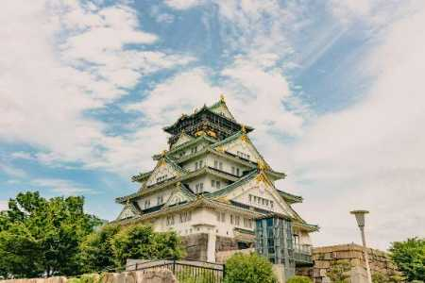
10:00 | › | Departure from hotel — Private Alphard (10hr hire)
10:30 | › | Optional: Osaka Castle (🍁 autumn foliage in the grounds)
12:00 | › | Transfer to KIX area — Lunch near airport
14:00 | › | Arrive Kansai International Airport (KIX)
14:30 | › | Check-in & security
20:00 | › | Alphard hire ends

🍁 AUTUMN LEAF PACKAGE Departure: 25 Nov – 10 Dec
Approx Price | 2 Adults | 4 Adults | 6 Adults
TOTAL PER PERSON (incl. 10% service charge) | ¥943,000 | ¥677,000 | ¥588,000

👦 CHILD ADD-ON RATE Age 12 & under | Co-sleeping · Breakfast included
Child Add-on Item | Per Child (Age 12 & under)
TOTAL ADD-ON PER CHILD (incl. 10% service charge) Co-sleeping · Breakfast included · Age 12 & under | ¥88,000
• Prices are a rough estimate per person based on twin/double room sharing. Hotel accommodation subject to availability and dynamic pricing.
• Child rate is an add-on to the adult package. Co-sleeping confirmed for ages 12 & under at all properties (Royal Park Ginza / Hotel Indigo Hakone Gora / Voco Osaka Central).
・Please make sure to inquire with us for the actual price and availability
・ Example: 4 Adults + 2 Children (Autumn) = ¥677,000 × 4 + ¥88,000 × 2 = ¥2,884,000 total

Al Tsunagaru Travel | Crafting Extraordinary Japan Experiences
This itinerary is subject to availability and final confirmation.

