
PROPOSED ITINERARY

TOKYO & HOKKAIDO SUMMER — 9 DAYS / 8 NIGHTS
Tokyo › Sapporo › Biei · Furano › Otaru › Shikotsu › Tokyo | Departure: 8 May – 5 Aug

DESTINATION  Tokyo · Hokkaido Sapporo · Furano | DURATION  9 Days / 8 Nights | TRAVEL DATES  15 Jun – 10 Aug | GUESTS

DETAILED ITINERARY
DAY 1 | ARRIVAL IN TOKYO
International Arrival · Airport Transfer · Welcome Dinner
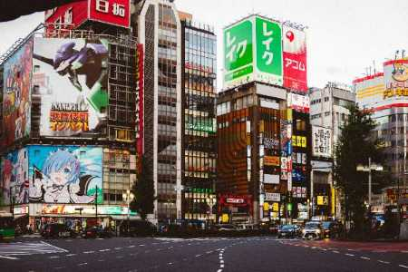
— | › | International flight arrives NRT / HND
— | › | Airport transfer to hotel — Private Alphard
— | › | Check-in: Upper Upscale Hotel Tokyo (4–5★)
20:00 | › | Welcome dinner — Shinjuku Teppanyaki
21:30 | › | Evening stroll: Shinjuku neon lights
DAY 2 | TOKYO SIGHTSEEING
Asakusa · Harajuku · Shibuya · Kimono
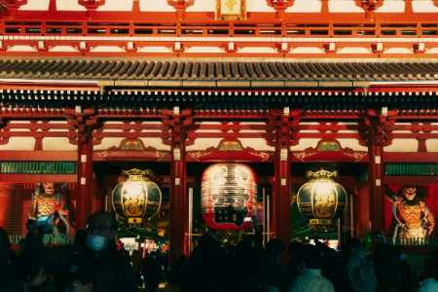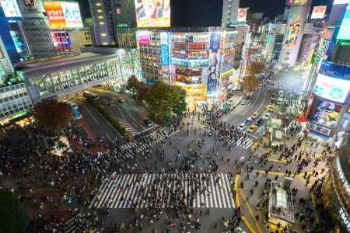
10:00 | › | Departure from hotel — Private Alphard (10hr hire)
10:30 | › | Asakusa: Senso-ji Temple & Nakamise Shopping Street
12:00 | › | Transfer to Harajuku / Omotesando
13:00 | › | Lunch — Japanese or International cuisine, Omotesando
14:30 | › | Harajuku shopping & Takeshita Street
16:00 | › | Shibuya Crossing & rooftop skyline views
17:30 | › | Kimono Wearing + Traditional Tea Ceremony
19:30 | › | Return to hotel
20:00 | › | Alphard hire ends
DAY 3 | TOKYO → SAPPORO ✈
Domestic Flight (Optional) · Sapporo Arrival · City Highlights
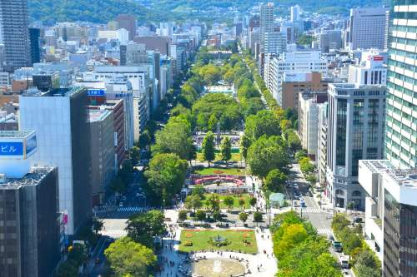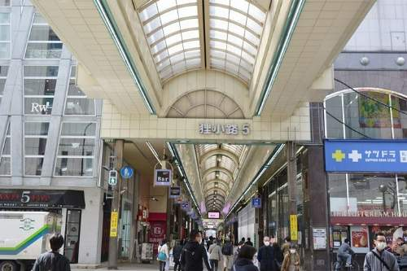
— | › | Tokyo (HND) → New Chitose Airport (CTS) — Domestic flight ✈ Optional
— | › | Approx. 1hr 30min flight
— | › | Private transfer: New Chitose → Sapporo Hotel — Alphard
— | › | Check-in: Upper Upscale Hotel Sapporo (4–5★)
13:00 | › | Lunch — Sapporo Soup Curry or Ramen
14:30 | › | Odori Park & Sapporo TV Tower
16:00 | › | Sapporo Beer Museum & tasting
18:00 | › | Susukino evening — fresh seafood dinner
20:00 | › | Return to hotel
DAY 4 | BIEI & FURANO 🌸
Blue Pond · Patchwork Hills · Lavender Fields · Farm Tomita
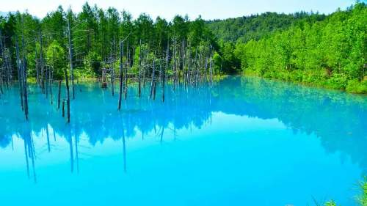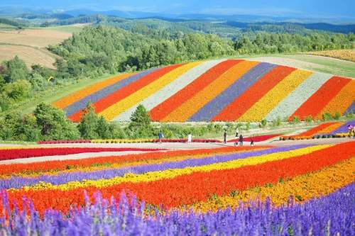
09:00 | › | Departure from hotel — Private Alphard (10hr hire)
10:30 | › | Arrive Biei — Blue Pond (青い池)
11:30 | › | Biei Patchwork Road scenic drive — rolling flower hills
13:00 | › | Lunch — Furano local restaurant (Omelet rice / farm cuisine)
14:30 | › | Furano Flower Fields — lavender & seasonal blooms 🌸
15:30 | › | Farm Tomita — lavender ice cream & flower garden
17:00 | › | Ningle Terrace — artisan craft village
18:30 | › | Return drive to Sapporo
20:00 | › | Arrive Sapporo — Alphard hire ends
DAY 5 | YOICHI & OTARU
Fruit Picking · Nikka Distillery · Otaru Canal · Sushi
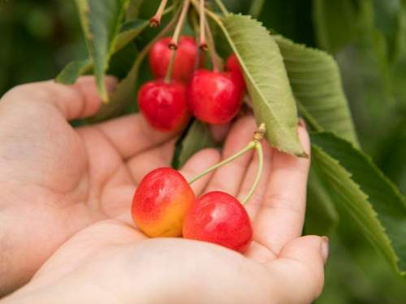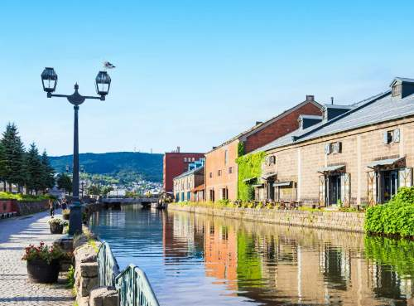
10:00 | › | Departure from hotel — Private Alphard (10hr hire)
11:00 | › | Arrive Yoichi — Fruit picking (cherries / melon / berries in season)
12:00 | › | Yoichi Nikka Whisky Distillery visit
13:00 | › | Lunch — Yoichi fresh seafood
14:30 | › | Arrive Otaru — Otaru Canal stroll
15:30 | › | Otaru Glasswork studios & music box shops
16:30 | › | Otaru Sushi Street — premium Hokkaido sushi
18:00 | › | Return to Sapporo
20:00 | › | Alphard hire ends
DAY 6 | LAKE SHIKOTSU → TOKYO ✈
Caldera Lake · Nature · New Chitose → Tokyo (Optional)
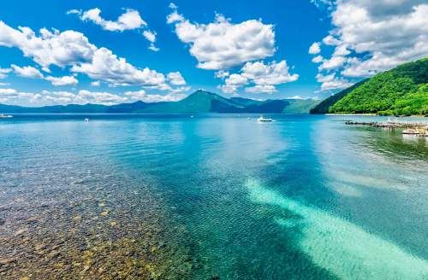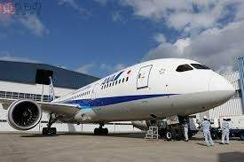
09:00 | › | Departure from hotel — Private Alphard (10hr hire)
10:00 | › | Arrive Lake Shikotsu — one of Japan's clearest caldera lakes
10:30 | › | Lake cruise or kayak experience
11:30 | › | Shikotsu Kohan: hot spring foot bath & lakeside walk
13:00 | › | Lunch — lakeside restaurant
14:30 | › | Transfer to New Chitose Airport (CTS)
16:00 | › | Arrive CTS — check-in & shopping at airport
— | › | New Chitose (CTS) → Tokyo (HND) — Domestic flight ✈ Optional
20:00 | › | Alphard hire ends
DAY 7 | TOKYO — TRANSIT DAY
Hotel Check-in · Rest & Relax
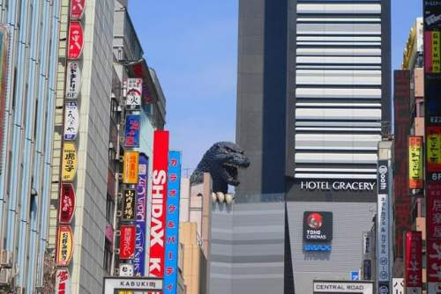
— | › | Arrive Tokyo HND — Private Alphard airport transfer
— | › | Check-in: Upper Upscale Hotel Tokyo (4–5★)
— | › | Free evening — rest & relax
DAY 8 | TOKYO SIGHTSEEING
teamLab · Ginza · Shopping · Farewell Dinner
10:00 | › | Departure from hotel — Private Alphard (10hr hire)
10:30 | › | teamLab Planets or teamLab Borderless — digital art immersion
13:00 | › | Lunch — Toyosu or Shiodome area
14:30 | › | Ginza — luxury shopping & gallery stroll
16:30 | › | Harajuku / Omotesando or Shibuya for last-minute shopping
18:30 | › | Farewell dinner — Teppanyaki or Wagyu Yakiniku
20:00 | › | Alphard hire ends
DAY 9 | DEPARTURE
Airport Transfer · Sayonara Japan!
— | › | Check-out & luggage preparation
— | › | Airport transfer: Hotel → NRT / HND — Private Alphard
— | › | Departure — Sayonara Japan! 🌸

🌸 SUMMER PACKAGE Tokyo & Hokkaido | Departure: 8 May – 5 Aug
Approx Price | 2 Adults | 4 Adults | 6 Adults
TOTAL PER PERSON (incl. 10% service | ¥654,000 | ¥437,000 | ¥364,000

Child Add-on Item | Per Child (Age 12 & under)
TOTAL ADD-ON PER CHILD (incl. 10% service charge) Co-sleeping · Breakfast included · Age 12 & under | ¥70,000
• Domestic flights Tokyo ↔ Hokkaido are optional and not included in the package rate.
• Example: 4 Adults + 2 Children = ¥437,000 × 4 + ¥28,000 × 2 = ¥1,804,000 total
• Please make sure to inquire with us for the actual price and availability.

Al Tsunagaru Travel | Crafting Extraordinary Japan Experiences
This itinerary is subject to availability and final confirmation. ✈ Domestic flights are optional and not included in the package rate.

