
PROPOSED ITINERARY

JAPAN DISCOVERY — 7 DAYS / 6 NIGHTS
Tokyo › Hakone › Osaka › Kyoto | Indian Couple | Departure: 8 May – 5 Aug

DESTINATION  Tokyo · Hakone Osaka · Kyoto | DURATION  7 Days / 6 Nights | TRAVEL DATES  8 May – 5 Aug | GUESTS  2 Adults (Couple)

DETAILED ITINERARY
DAY 1 | ARRIVAL IN TOKYO
Airport Transfer · Welcome Dinner · Hotel Check-in
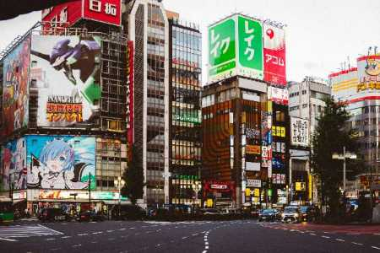
10:00 | › | Departure from hotel — Airport pickup / Hotel check-in (private vehicle)
— | › | Airport transfer: NRT/HND → Hotel (upon arrival)
— | › | Check-in & freshen up at Upper Upscale Hotel (4–5★)
20:00 | › | Welcome dinner — Shinjuku Teppanyaki restaurant
21:30 | › | Evening stroll: Shinjuku neon lights
DAY 2 | TOKYO SIGHTSEEING
Asakusa · Harajuku · Shibuya · Kimono
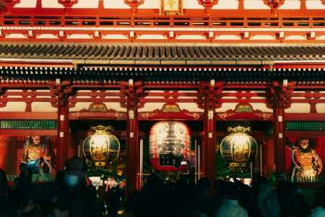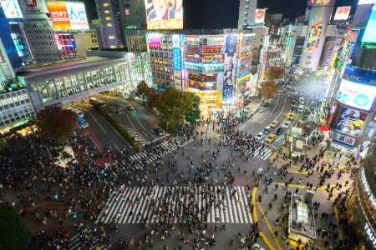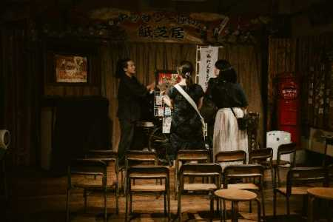
10:00 | › | Departure from hotel — Private Hiace (10hr hire)
10:30 | › | Asakusa: Senso-ji Temple & Nakamise Shopping Street
12:00 | › | Transfer to Harajuku / Omotesando
13:00 | › | Lunch — Japanese or International cuisine, Omotesando
14:30 | › | Harajuku shopping & Takeshita Street
16:00 | › | Shibuya Crossing & rooftop skyline views
17:30 | › | Kimono Wearing + Traditional Tea Ceremony
19:30 | › | Return to hotel
20:00 | › | Hiace hire ends
DAY 3 | TOKYO → HAKONE
Mt. Fuji · Lake Ashi · Onsen Ryokan
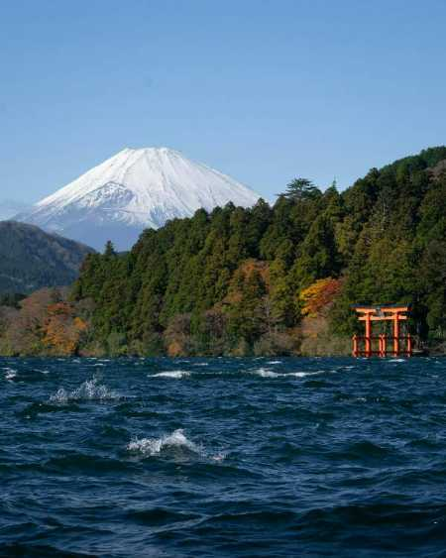
10:00 | › | Departure from hotel — Private Hiace (10hr hire)
11:30 | › | Arrive Hakone — Hakone Open Air Museum
13:00 | › | Lunch — lakeside restaurant, Hakone
14:30 | › | Lake Ashi Cruise with Mt. Fuji views *(weather permitting)*
16:00 | › | Owakudani volcanic valley & black eggs experience
17:00 | › | Check-in: Luxury Onsen Ryokan (4–5★)
18:00 | › | Private onsen & relax
19:00 | › | Kaiseki multi-course dinner at ryokan
20:00 | › | Hiace hire ends
DAY 4 | HAKONE → OSAKA
Shinkansen Green Car · Osaka Check-in · Dotonbori
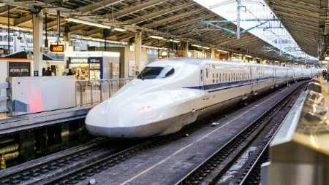
09:00 | › | Ryokan breakfast & morning onsen
10:00 | › | Private transfer to Mishima Station
10:45 | › | Shinkansen: Mishima → Shin-Osaka (Green Car / 1st Class)
12:15 | › | Arrive Shin-Osaka — Check-in: Upper Upscale Hotel (4–5★)
13:00 | › | Lunch — Shinsaibashi area restaurant
15:00 | › | Free time — Osaka Castle or Namba shopping
18:00 | › | Dotonbori night walk & Osaka street food experience
20:00 | › | Return to hotel
DAY 5 | KYOTO DAY TRIP
Fushimi Inari · Arashiyama · Samurai
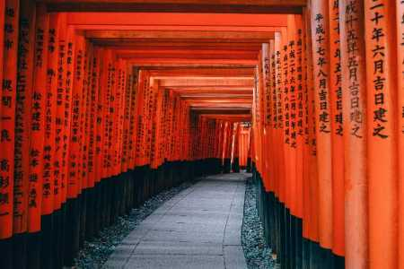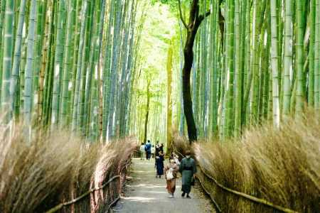
10:00 | › | Departure from hotel — Private Hiace (10hr hire)
11:00 | › | Arrive Kyoto — Fushimi Inari Taisha (torii gates)
13:00 | › | Lunch — Kyoto Obanzai / Kaiseki light
14:30 | › | Arashiyama: Bamboo Grove & Tenryu-ji Zen Garden
16:00 | › | Nishiki Market — food & souvenir shopping
17:00 | › | Samurai Experience or Zen Meditation Session
18:30 | › | Return to Osaka
20:00 | › | Hiace hire ends
DAY 6 | UNIVERSAL STUDIOS JAPAN + SHOPPING
USJ · Shinsaibashi · Farewell Dinner
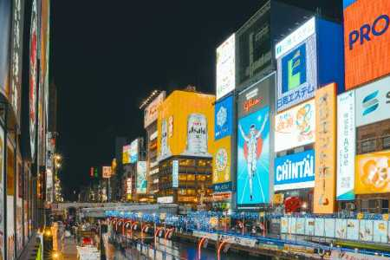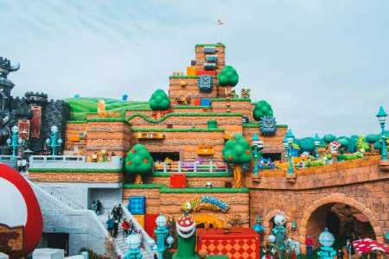
10:00 | › | Departure from hotel — Private Hiace (10hr hire)
10:15 | › | Arrive Universal Studios Japan (USJ)
10:30 | › | USJ opens — Full day (Express Pass strongly recommended)
13:00 | › | Lunch inside USJ
18:00 | › | Depart USJ
18:30 | › | Shinsaibashi / Amerikamura evening shopping
19:30 | › | Farewell dinner: Premium Wagyu Yakiniku or Osaka Kappo
20:00 | › | Hiace hire ends
DAY 7 | DEPARTURE FROM OSAKA
Kansai International Airport · Sayonara!
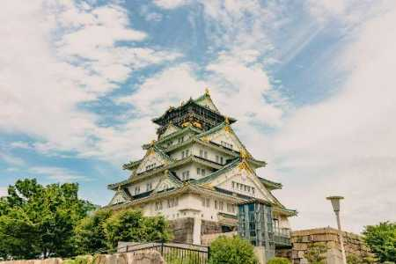
10:00 | › | Departure from hotel — Private Hiace (10hr hire)
10:30 | › | Optional: Osaka Castle grounds visit
12:00 | › | Transfer to KIX area — Lunch near airport
14:00 | › | Arrive Kansai International Airport (KIX)
14:30 | › | Check-in & security (recommended 3hrs before departure)
20:00 | › | Hiace hire ends

🌞 SUMMER PACKAGE Departure: 8 May – 5 Aug
Approx price | 2 Adults | 4 Adults | 6 Adults
TOTAL PER PERSON (incl. 10% service charge) | ¥891,000 | ¥625,000 | ¥536,000

👦 CHILD ADD-ON RATE Age 12 & under | Co-sleeping · Breakfast included
Child Add-on Item | Per Child (Age 12 & under)
TOTAL ADD-ON PER CHILD (incl. 10% service charge) Co-sleeping · Breakfast included · Age 12 & under | ¥88,000
• Prices are per person based on twin/double room sharing. Hotel accommodation subject to availability and dynamic pricing.
• Child rate is an add-on to the adult package. Co-sleeping confirmed for ages 12 & under at all properties (Royal Park Ginza / Hotel Indigo Hakone Gora / Voco Osaka Central).
• Example: 4 Adults + 2 Children (Summer) = ¥625,000 × 4 + ¥88,000 × 2 = ¥2,676,000 total
• Please make sure to inquire with us for the actual price and availability.

Al Tsunagaru Travel | Crafting Extraordinary Japan Experiences
This itinerary is subject to availability and final confirmation. Photos: Unsplash (CC0).

