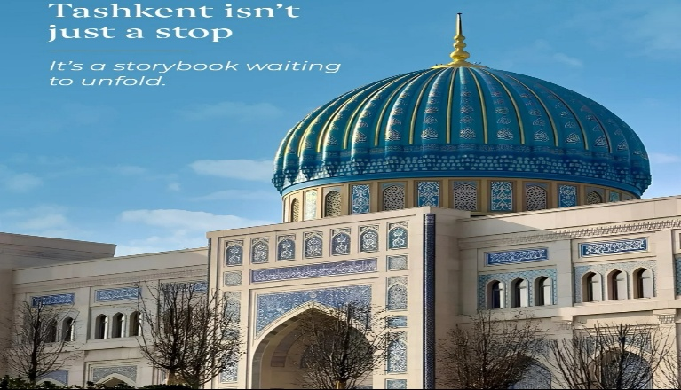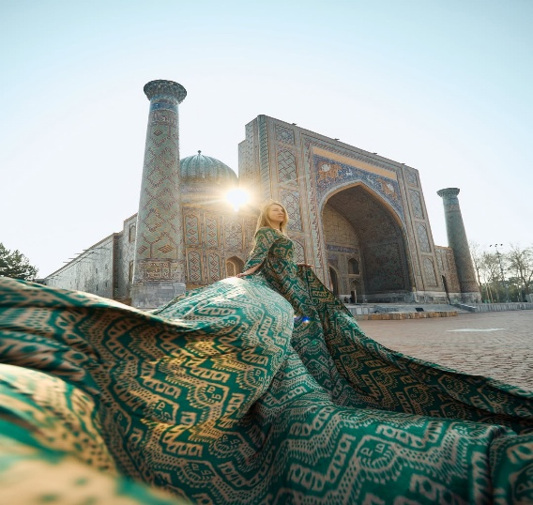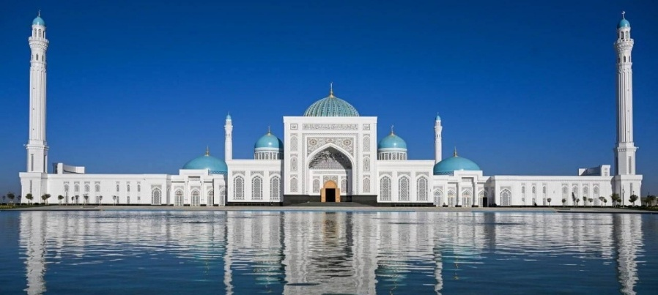
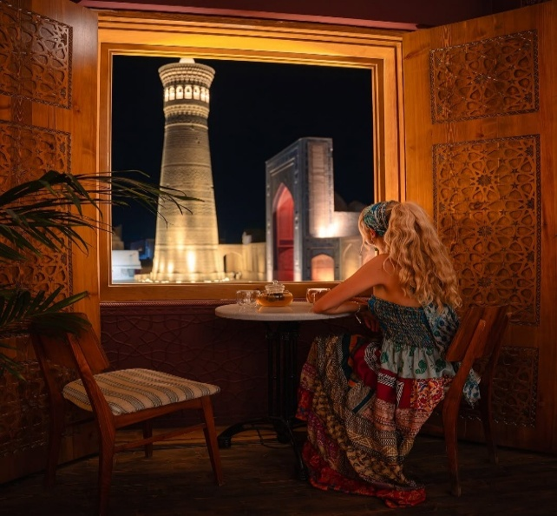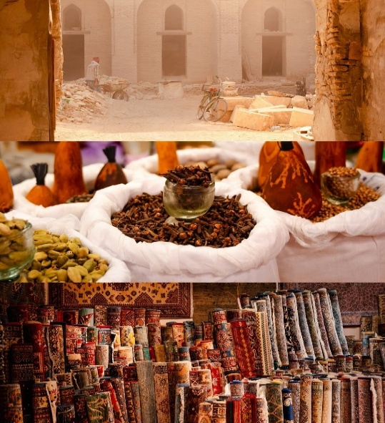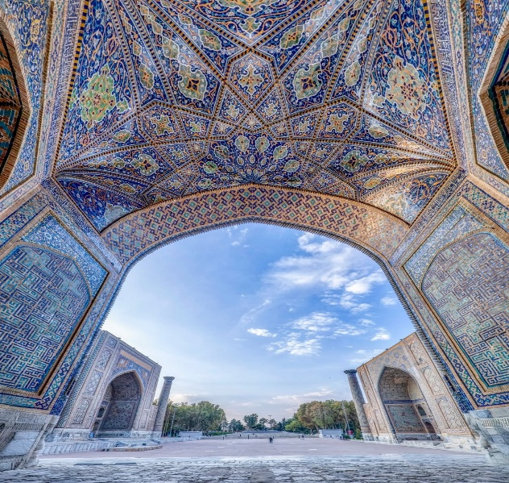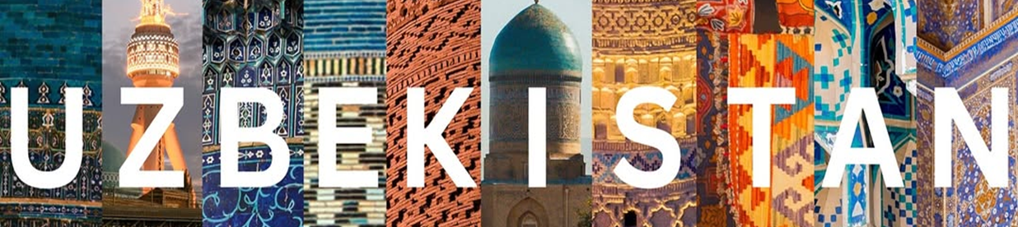
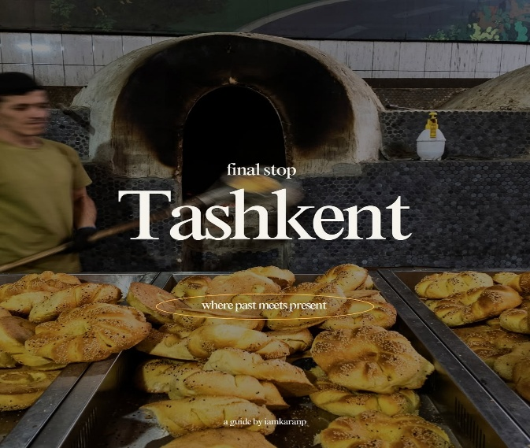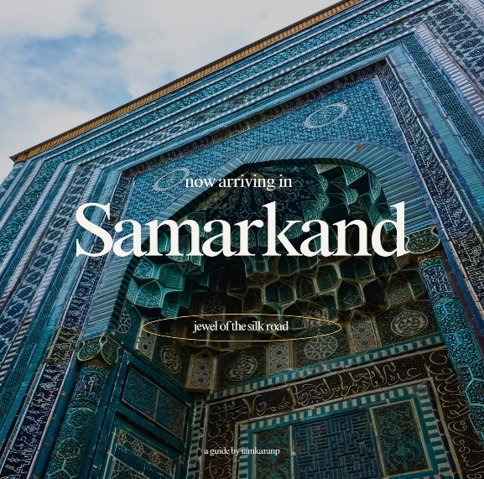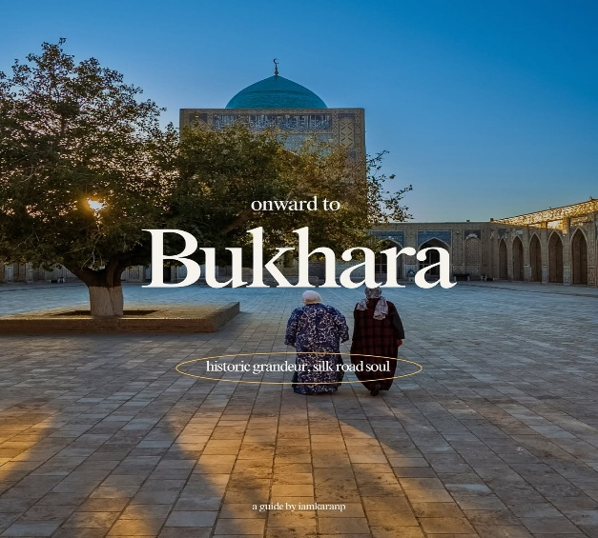
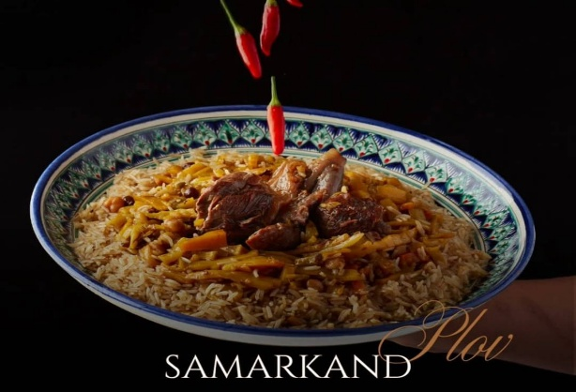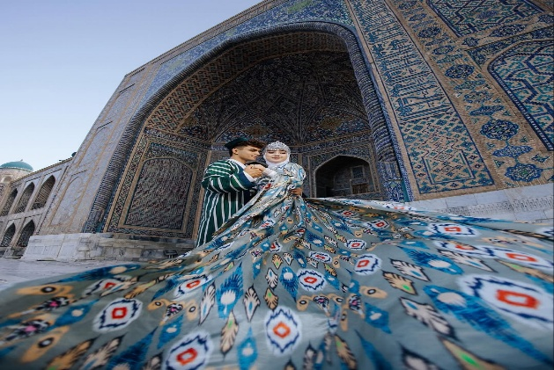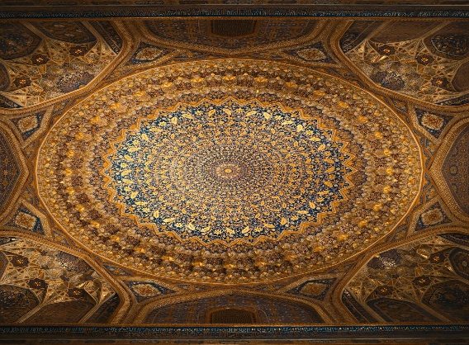

The Ancient Silk Road
Homeland of Great Amir Temur
TASHKENT- SAMARKAND-TASHKENT
4 Nights / 5 Days (2pax)
Day 1: Arrival Tashkent
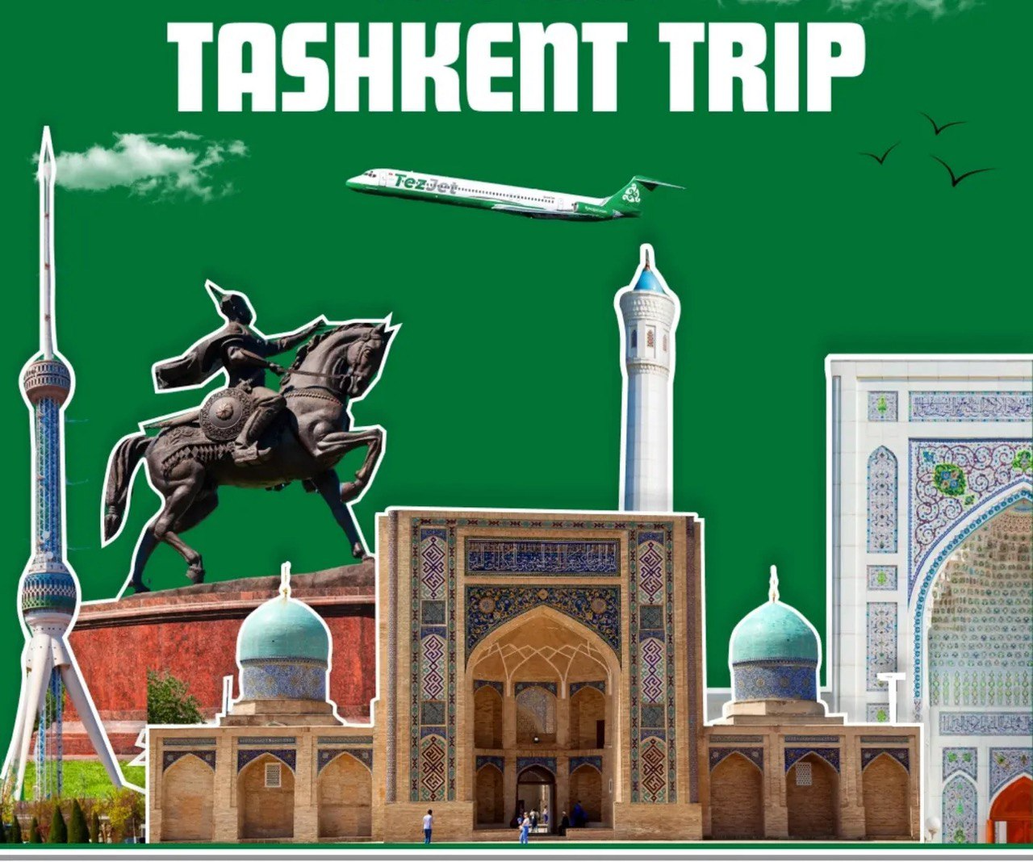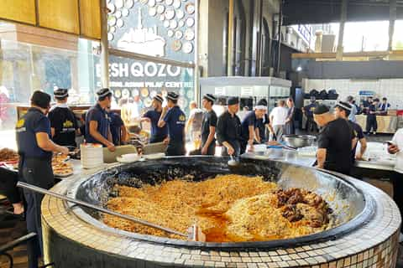
Tashkent Monuments Beshqozon Plov Center Tashkent
On your arrival Tashkent International Airport
Meet & Greet Service outside of arrival hall
Transfer to the hotel & check in and rest.
Overnight in Tashkent

Day 2: TASHKENT – SAMARKAND
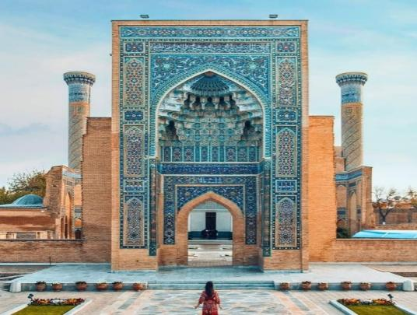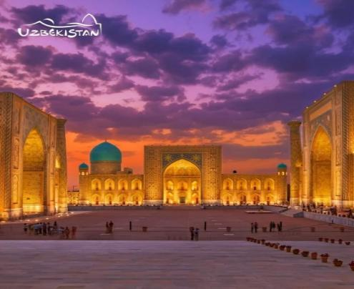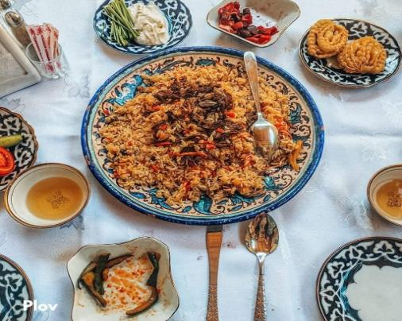
AMIR TEMUR MAQBARA REGISTAN SQUARE UZBEK PILAV
06.00-07:00 Early buffet breakfast at your hotel’s coffee shop.
07.00 Transfer Tashkent Railway station to take Tashkent-Samarkand Afrasiyab train (2 hours)
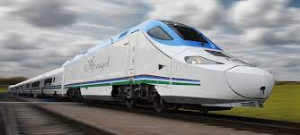
Arrival in Samarkand & start tour visiting with Guri Emir (Amir Temur) mausoleum (XIVc.) Registan Square (XV-XVIIc.) with 3 huge: Ulughbek, Shirdar & Tillakori Madrasas
13.00 Lunch at Uzbek restaurant by own
After lunch Paper factory village Konigil. Here you can see in your real eyes how to prepare paper from materials and ceramics, New Samarkand Eternal City.
Overnight in Samarkand

Day 3: Samarkand-Tashkent
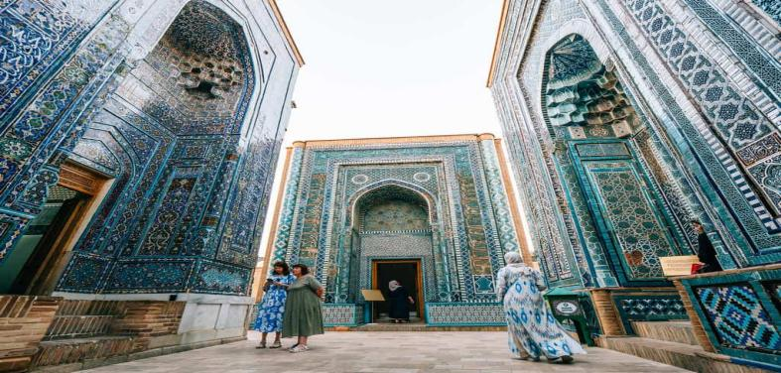
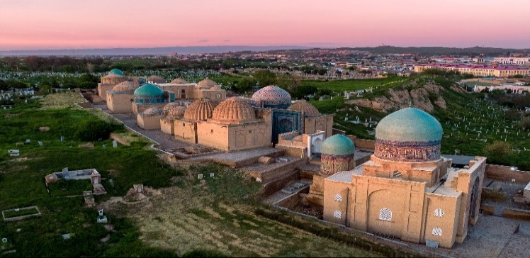
AMIR TEMUR MAQBARA REGISTAN SQUARE UZBEK PILAV
07.00-10.00 Enjoy buffet breakfast at your hotel’s coffee shop.
10:00 Full day City tour Samarkand: Shahi Zindah complex (IX-XIc.), Visiting Silk Carpet factory, Hazrati Hizir Masjid
Lunch at national Uzbek restaurant or local guest house with traditional foods by own
After lunch Transfer Samarkand Railway station to take Samarkand-Tashkent Afrasiyab train (2 hours)
Overnight Tashkent

Day 4: Tashkent City Tour
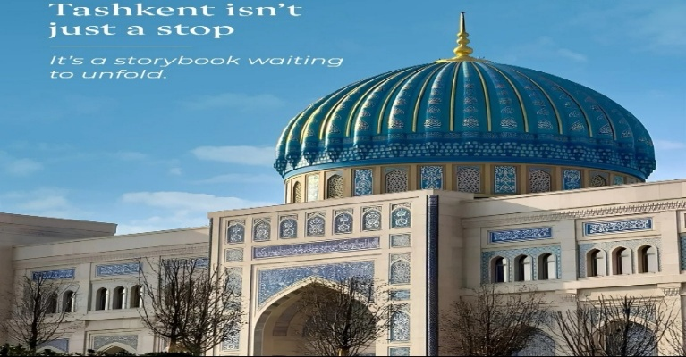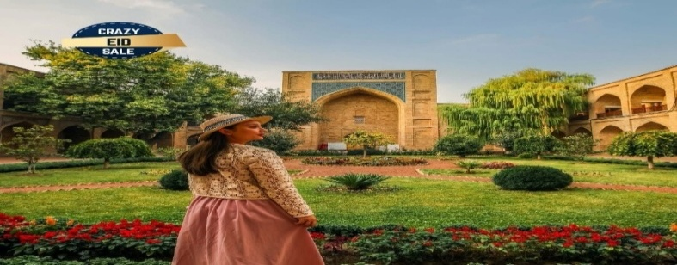
ISLAMIC CIVILIZATION CENTER KUKALDOSH MADRASA IN OLD TASHKENT
07.00-10:00 Enjoy buffet breakfast at your hotel’s coffee shop.
10:00 Full day city tour: Visit Hazrati Imam complex including Barakkhan madrasah (XVIc.), Hazrati Usman RA old Koran (VIIc.) museum, Juma Mosque (2007y) & Mausoleum of Hazrati Imam (lived in Xc.), Islamic Civilization Center-is the largest cultural, scientific, and educational complex in Uzbekistan. oriental and ancient Charsu Bazaar, one of the main Bazaars of Tashkent
Lunch at Uzbek restaurant
After lunch visit to TV tower (1985) from (outside) with Memorial Complex of Repression (2000), Minor Masjid, Monument of Courage, Tashkent metro stations: Modern Cosmaufts and oriental Alisher Navai metro stations, & Magic city Park & Seoul Mun Mall in Tashkent
Overnight Tashkent
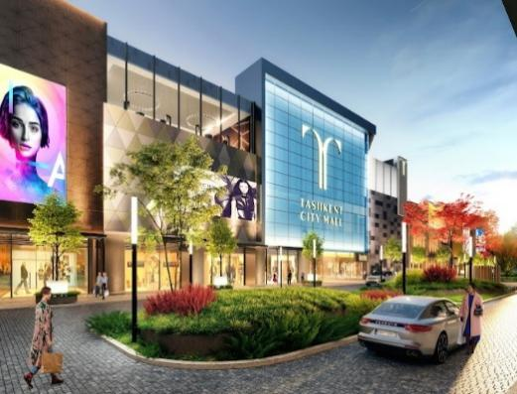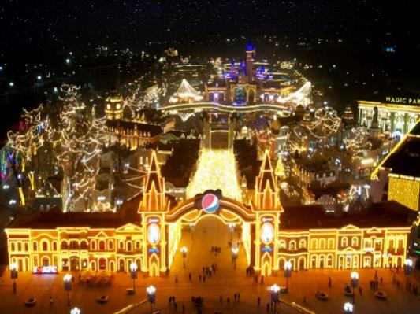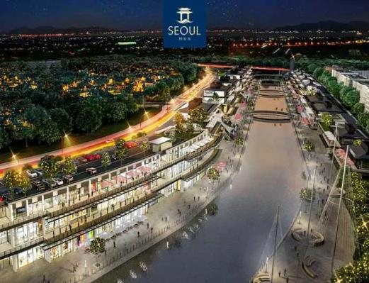
TASHKENT CITY MALL MAGIC CITY PARK SEOUL MUN TASHKENT

Day 5: Tashkent Departure
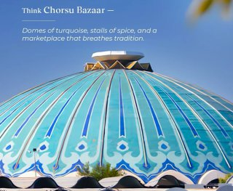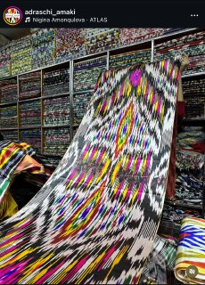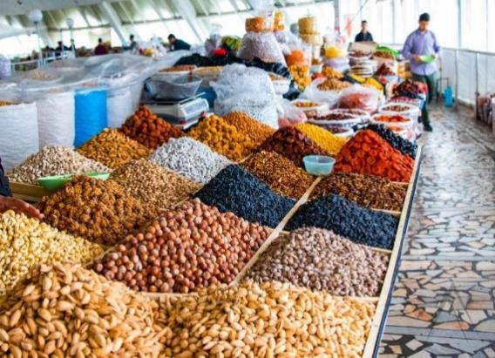
Charsu Bazaar Tashkent National Uzbek Dress Dried Fruits Tashkent
07.00-10:00 Enjoy buffet breakfast at your hotel’s coffee shop.
Transfer to International Tashkent Airport to take a flight Fly back to Home.
End of the tour! Have a nice flight!!!

Package includes:
- Accommodation on Twin/Double basis in 3/4* hotels in Tashkent & Samarkand with all Breakfasts;
- Services of Professional English-speaking tour guides;
- 2 bottles of 0.5 water per person in every day;
- One special traditional Uzbek gift from travel agency side;
- Afrosiyab bullet train tickets: Tashkent Samarkand -Tashkent economy class;
- Transportation and transfers all cities;

Not included:
- International air tickets;
- Early Check in & Late Check out;
- E-Visa fees;
- All entrance fees to the monuments tour itinerary in Tashkent, Samarkand, Amirsoy;
- Charges in hotels for additional services;
- Photography and video making fees at the sites;
- Personal insurance;
- Tips for tour guides and drivers;
- Services not included in the above itinerary

Package 3 * Hotels
2pax | Tashkent | Samarkand
425$ p/p | Loren/90/Art/Welcome | Yurt/Old City
440$ p/p | Art/Sato/Shosh/Lavanda | Marjon/Registan
455$ p/p | Orient/Avant/Art | Siab Boutique
470$ p/p | Garnet/Uzbekistan/Marmaris | Humo/Comfort /Astoria

Package 4 * Hotels
4pax | Tashkent | Samarkand
485$ p/p | Roadside/Suvon/Huvaydo | De Villa/ Amar
500$ p/p | Elements/Azimut | Samaria
520$ p/p | Grand Dior /Shamson | Noble/Siab
535$ p/p | Wyndham Garden/Ramada | Wellness Park
575$ p/p | Mercure/ Ichan Qala/ Bentley | Hilton Garden Inn

*ROOMS IN HOTELS AND TRAIN TICKETS AVAILABILITY FOR BULETT TRAIN “AFROSIAB” ARE NOT GUARANTEED AT THE TIME OF QUOTATION.CAN BE CHECKED UPON REQUEST.
Supplement cost of entry fees Tashkent & Amirsoy & Samarkand 80 USD p/p

Supplement cost of LUNCH 15 USD p/p

Supplement cost of DINNER 15 USD p/p

