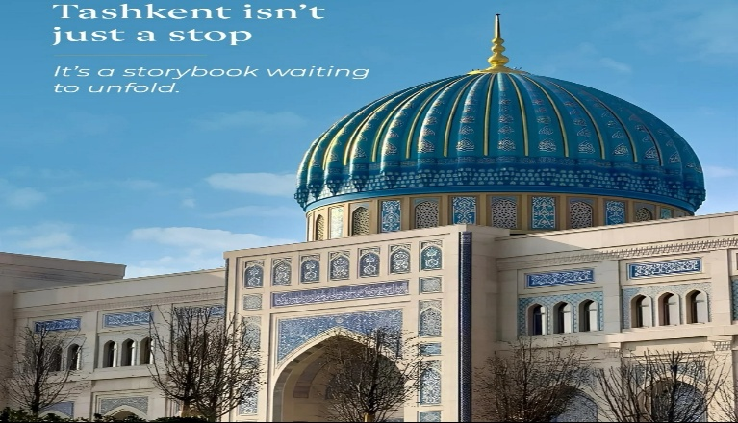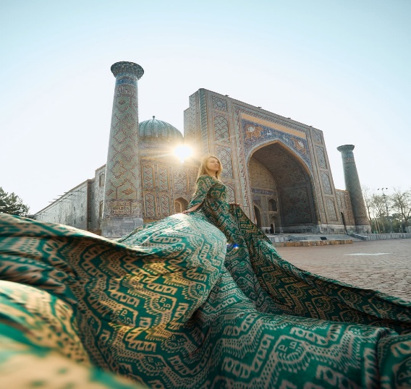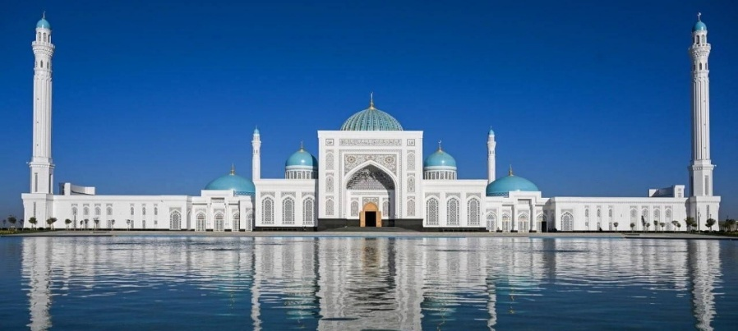
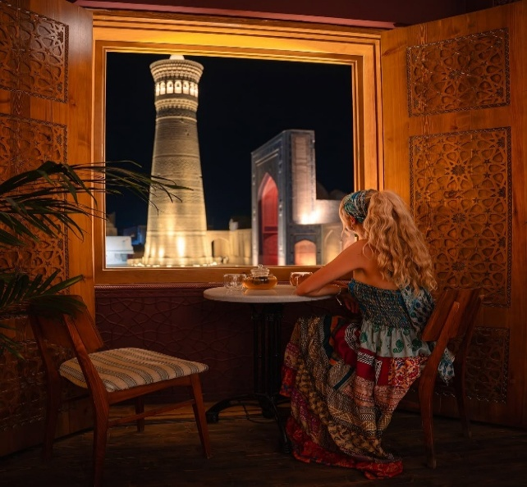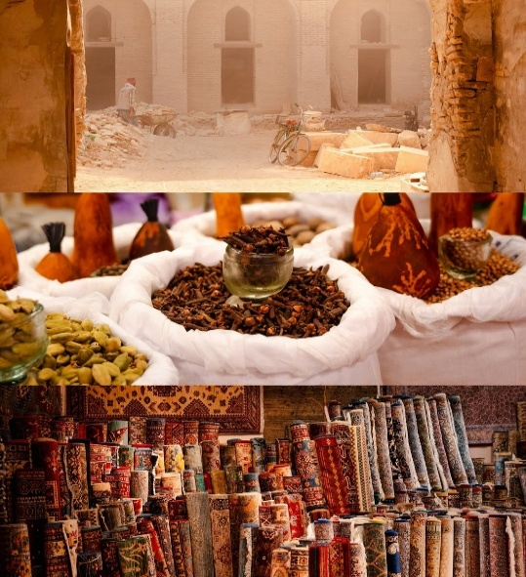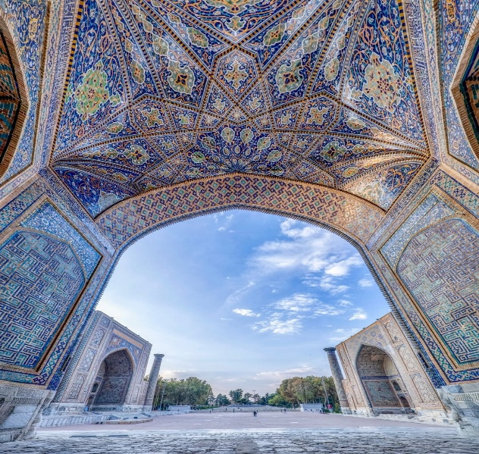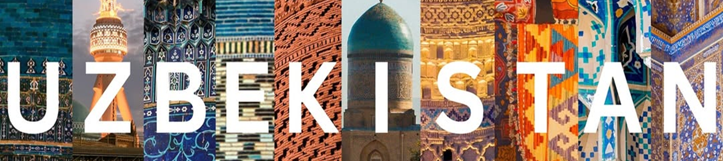
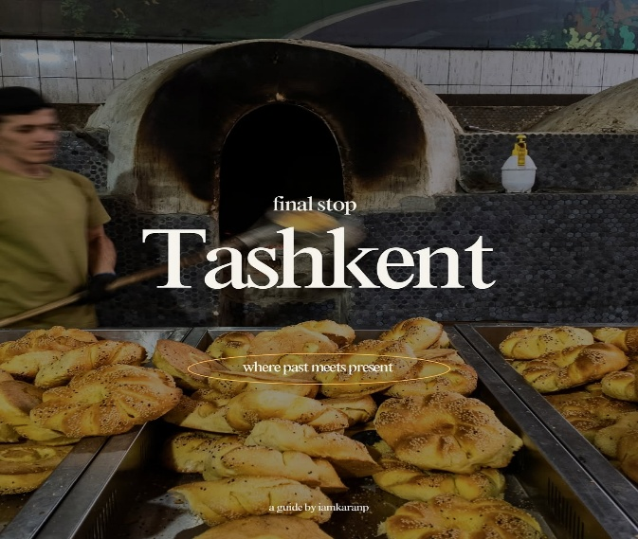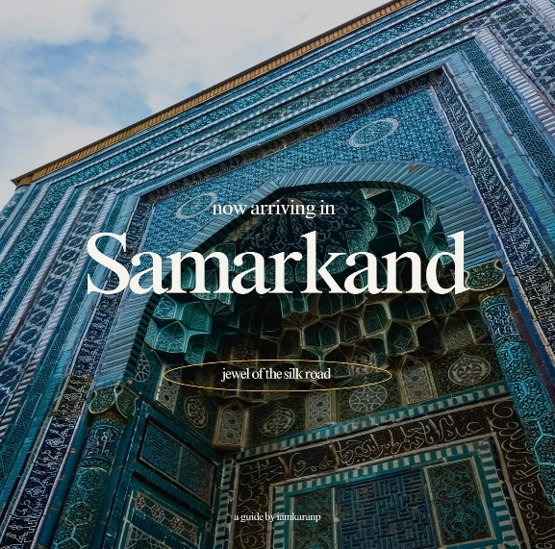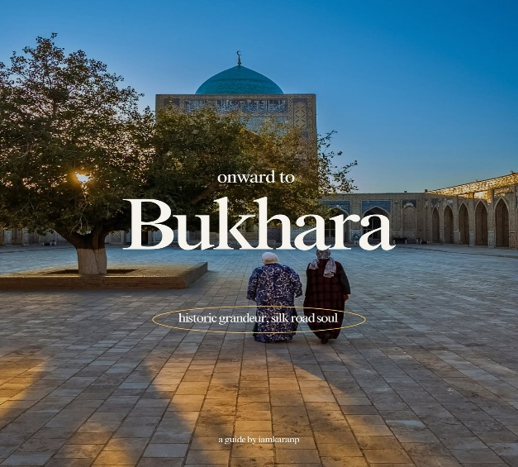
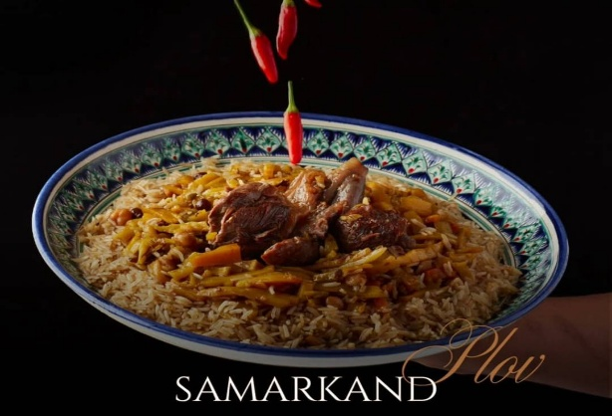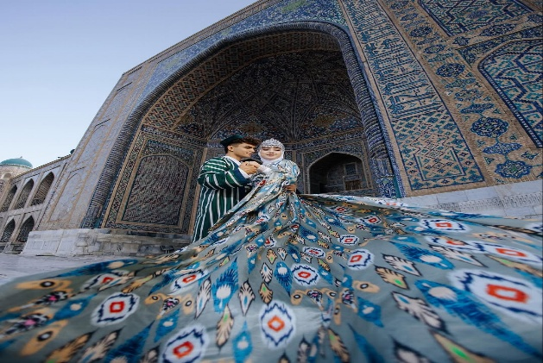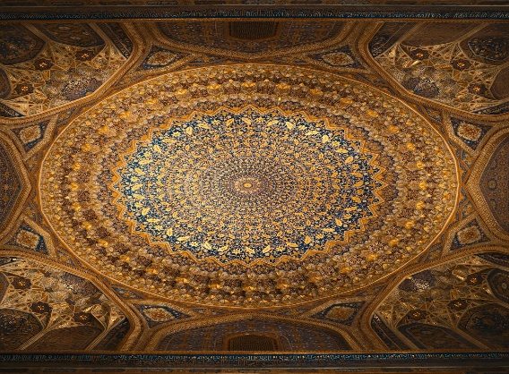

The Ancient Silk Road
Homeland of Great Amir Temur
TASHKENT-AMIRSOY-SAMARKAND-TASHKENT
5 Nights / 6 Days (2pax)
Day 1: Arrival Tashkent
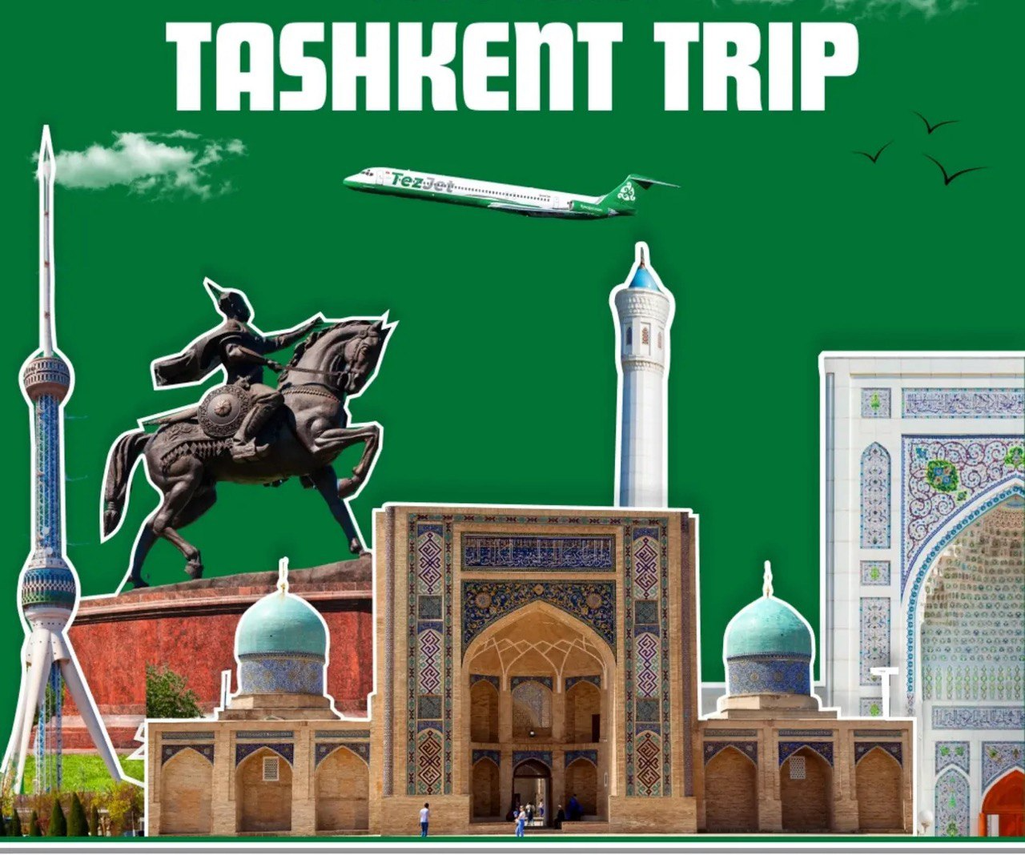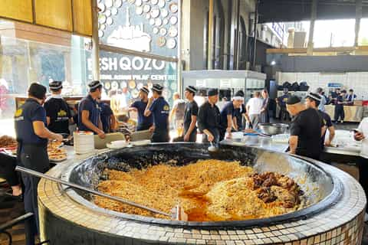
Tashkent Monuments Beshqozon Plov Center Tashkent
On your arrival Tashkent International Airport
Meet & Greet Service outside of arrival hall
Transfer to the hotel & check in and rest.
Free time in Tashkent
Overnight in Tashkent

Day 2: Tashkent Free day
07.00-10:00 Enjoy buffet breakfast at your hotel’s coffee shop.
10:00 Free day in Tashkent
Overnight in Tashkent

Day 3: Tashkent Amirsoy Resort/Chimgan Mountains & Charwak Lake
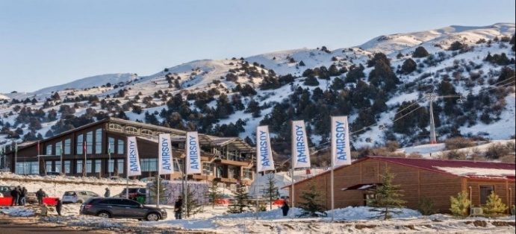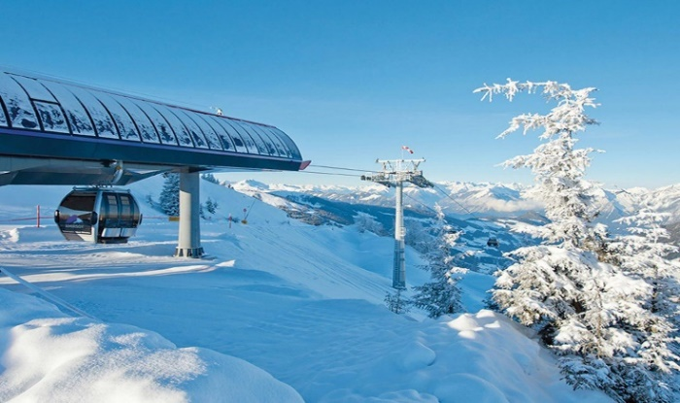
07.00-10:00 Enjoy buffet breakfast at your hotel’s coffee shop.
10:00 Mountain tour 1.5 Hours / 125 Kms drive to Chimgan Mountains and later to Charwak Lake.
11.30 Arrive in Amirsoy Resort. Ride on Chair Lift which brings you on top of mountains have fantastic
Lunch at local restaurant
Enjoy Free time at Beautiful Charwak Lake.
17.00 Drive back to Tashkent hotel & rest in the hotel
Overnight in Tashkent
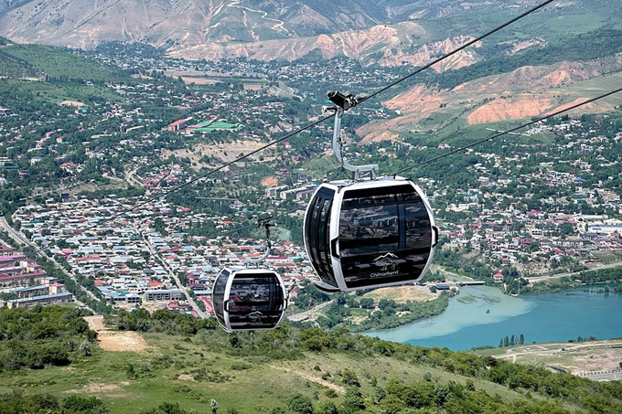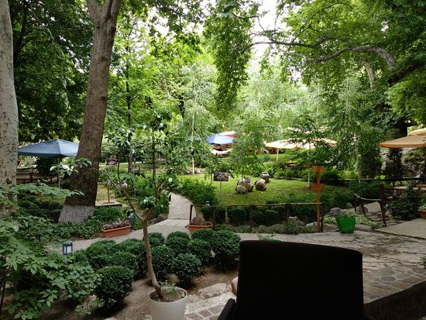

Day 4: Tashkent City Tour
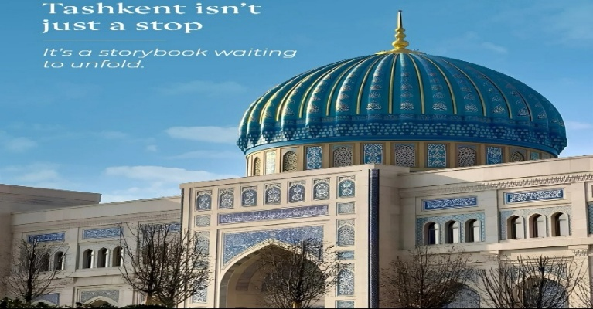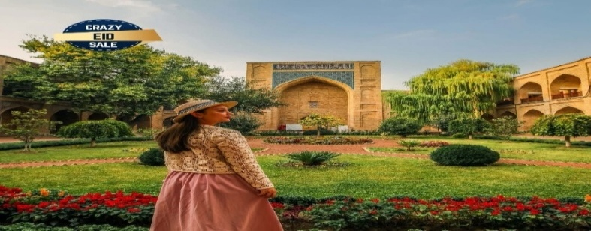
ISLAMIC CIVILIZATION CENTER KUKALDOSH MADRASA IN OLD TASHKENT
07.00-10:00 Enjoy buffet breakfast at your hotel’s coffee shop.
10:00 Full day city tour: Visit Hazrati Imam complex including Barakkhan madrasah (XVIc.), Hazrati Usman RA old Koran (VIIc.) museum, Juma Mosque (2007y) & Mausoleum of Hazrati Imam (lived in Xc.), Islamic Civilization Center-is the largest cultural, scientific, and educational complex in Uzbekistan.
Lunch at Uzbek restaurant
After lunch visit to TV tower (1985) from (outside) with Memorial Complex of Repression (2000), Minor Masjid, Monument of Courage, Tashkent metro stations: Modern Cosmaufts and oriental Alisher Navai metro stations,
Overnight Tashkent
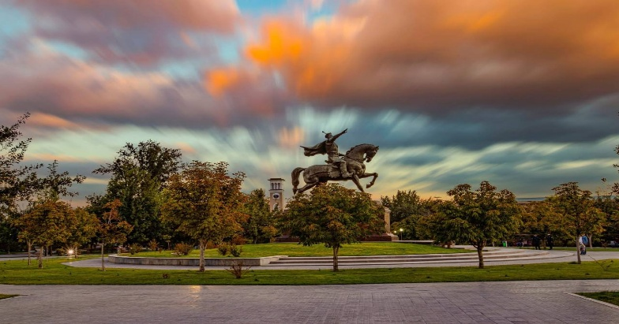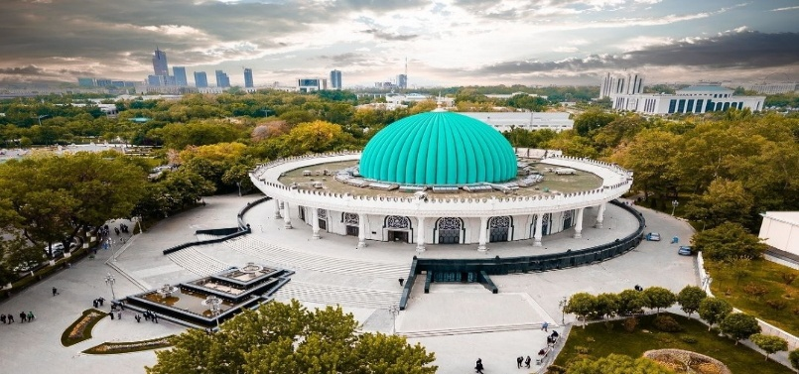
AMIR TEMUR SQUARE TASHKENT AMIR TEMUR MUSEUM TASHKENT

Day 5: Tashkent Shopping Tour
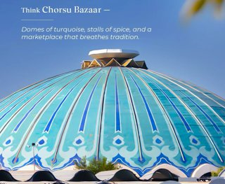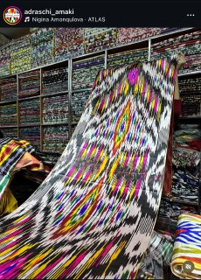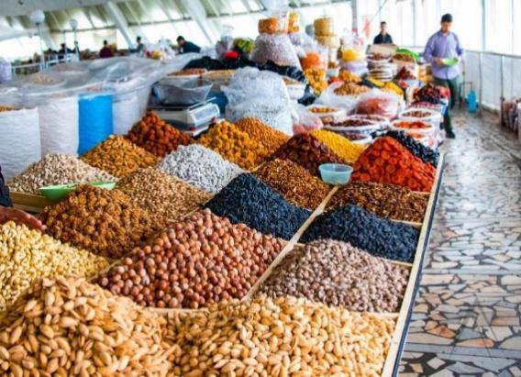
Charsu Bazaar Tashkent National Uzbek Dress Dried Fruits Tashkent
07.00-10:00 Enjoy buffet breakfast at your hotel’s coffee shop.
10:00 Full day city tour: oriental and ancient Charsu Bazaar, one of the main Bazaars of Tashkent
Lunch at Uzbek restaurant
After lunch Tashkent City Hyper mall with Tashkent city Park & Magic city Park & Seoul Mun Mall in Tashkent
Overnight in Tashkent
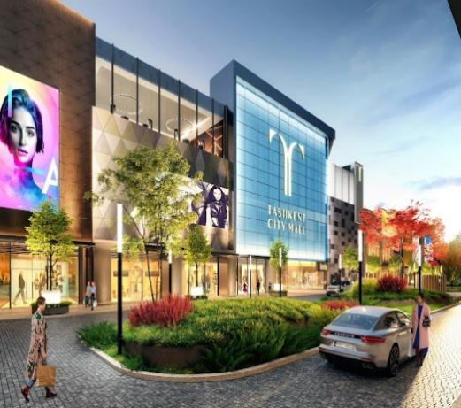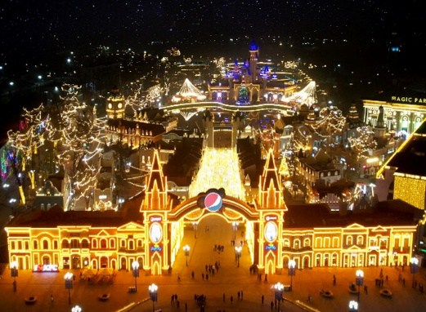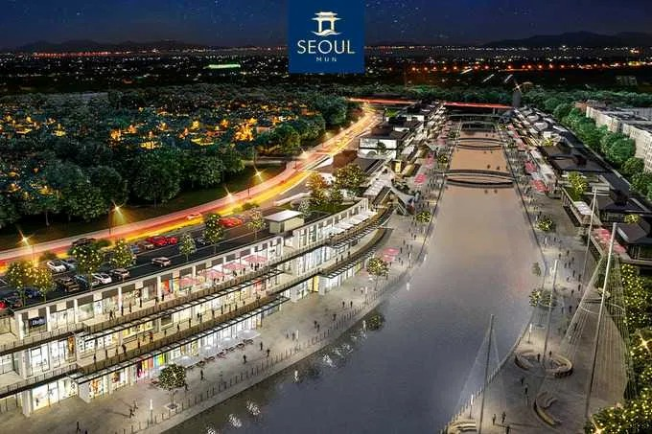
TASHKENT CITY MALL MAGIC CITY PARK SEOUL MUN TASHKENT
Day 6: Tashkent Departure
Charsu Bazaar Tashkent National Uzbek Dress Dried Fruits Tashkent
07.00-10:00 Enjoy buffet breakfast at your hotel’s coffee shop.
Transfer to International Tashkent Airport to take a flight Fly back to Home.
End of the tour! Have a nice flight!!

Package includes:
- 5 Nights Accommodation on Twin/Double basis in 3/4* hotels in Tashkent with all Breakfasts;
- Services of Professional English-speaking tour guides;
- 2 bottles of 0.5 water per person in every day;
- Transportation and transfers all cities;

Not included:
- International air tickets;
- Early Check in & Late Check out;
- E-Visa fees;
- All entrance fees to the monuments tour itinerary in Tashkent, Amirsoy;
- Charges in hotels for additional services;
- Photography and video making fees at the sites;
- Personal insurance;
- Tips for tour guides and drivers;
- Services not included in the above itinerary

Package 3 * Hotels
2pax | Tashkent
335$ p/p | Loren/90/Art/Welcome
350$ p/p | Art/Sato/Shosh/Lavanda
365$ p/p | Orient/Avant/Art
380$ p/p | Ibis/Uzbekistan/Garnet

Package 4 * Hotels
2pax | Tashkent
395$ p/p | Roadside/Huvaydo/Marwa/Merhaba
420$ p/p | Elements/Azimut/Unique/King Plaza
435$ p/p | Grand Dior/Shamson/Simma
450$ p/p | Wyndham Garden/Ramada/City Palace
476$ p/p | Mercure/Ichan Qala/Bentley/Frankfort

*ROOMS IN HOTELS ARE NOT GUARANTEED AT THE TIME OF QUOTATION.CAN BE CHECKED UPON REQUEST.
Supplement cost of entry fees Tashkent & Amirsoy 50 USD p/p

Supplement cost of LUNCH 15 USD p/p

Supplement cost of DINNER 15 USD p/p

